**Project Report Template**

**INTRODUCTION**

1.1 Overview

The process of creating infographics is sometimes referred to as data visualization. Designers start by researching the topic and gathering data and then organizing it into a visual format. This can include creating charts, graphs, maps, timelines or other visuals to help tell the story.

1.2 Purpose

When it comes to designing an effective infographic, it's important to recognize that our brain seeks patterns in visual information to help us make sense of the world. We can use this idea to structure our information visually and create patterns that will enhance the message that we're trying to communicate.

**Problem definition & design thinking**

2.1 Empathy map

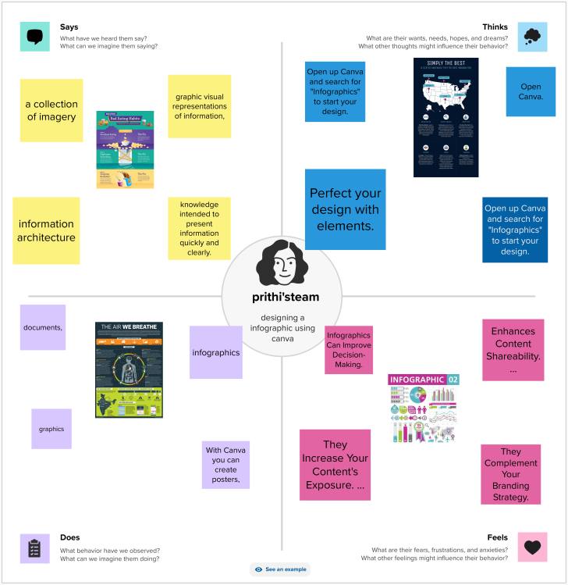

2.2 Brainstroming

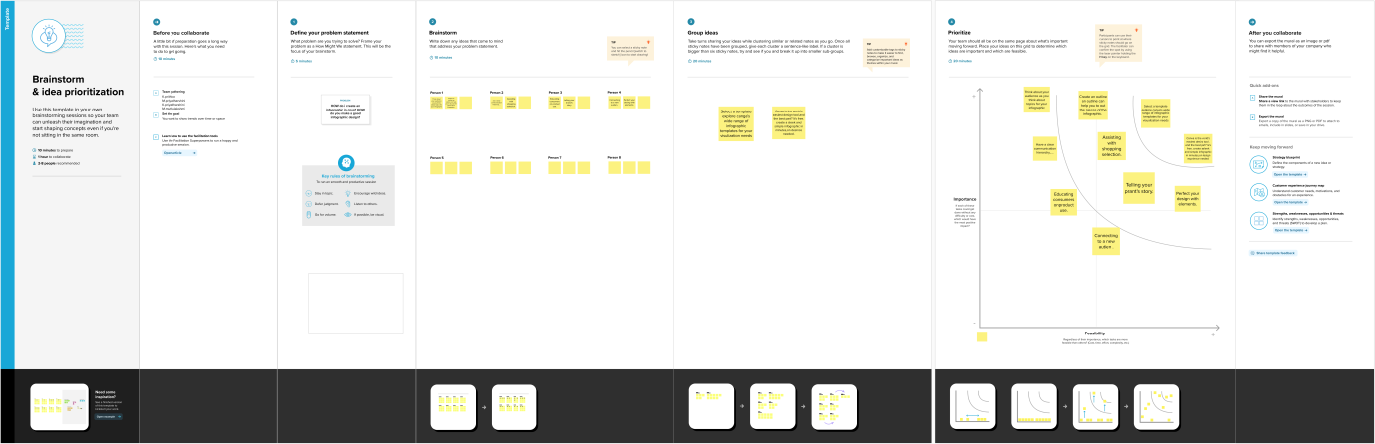

**RESULT**

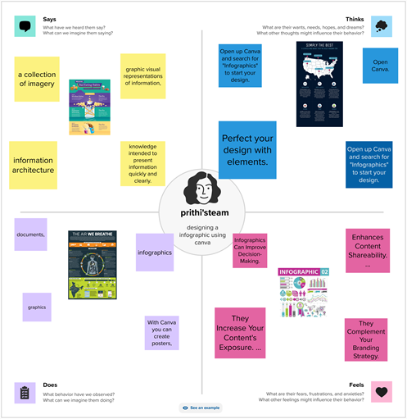

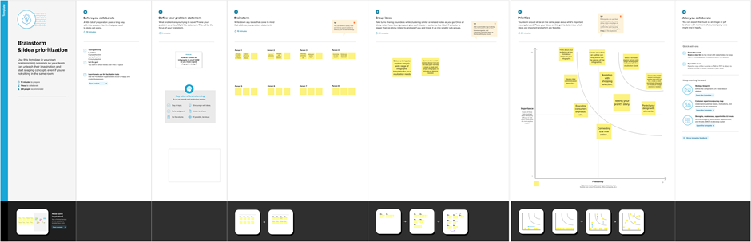

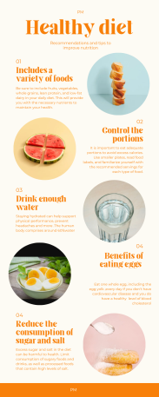

**ADVANTAGES & DISADVANTAGES**

Advantages

* Visual Attraction. First and foremost, infographics are visually appealing. ...
* Optimized Readability. Infographics are amazing because they are really easy to read, understand and more importantly, to remember them. ...
* Brand Credibility. ...
* Branding Strategy. ...
* Website Visitors. ...
* Improved SEO. ...
* Easy Tracking.

Disadvantages

* Mostly behind a computer. Graphic designers spend most of their days behind a computer. ...
* Limited promotion opportunities. As a graphic designer, there are limited opportunities to progress your career. ...
* Often work alone. ...
* Deadlines. ...
* Must meet client specifications.

**APPLICATION**

* Choose your desired infographic template.
* Decide on a goal for your infographic.
* Identify the audience for your infographic.
* Collect your content and relevant data.
* Download your template to PowerPoint.
* Customize your infographic.
* Include a footer with your sources and logo.
* Promote and publish your infographic.

**CONCLUSION**

Infographics guide your audience towards a particular conclusion, while data visualization presents all the information and allows your audience to come to their own conclusions. This is the biggest difference between these two visual elements**.**

**FUTURE SCOPE**

A good conclusion essentially looks like a triangle (or “upside-down funnel”), which is the opposite of an introduction. We start with the specific and move into the general. Don't simply repeat what you've already stated in your paper, demonstrate how they fit together.